User Manual

Program: Homework 5.cpp

This program welcomes you to floodFill. It then asks you which location at which you would like to begin the filling process. If you select invalid location, it will asks you to try again. The floodfill process will then proceed, filling all possible 0’s that are contained within the figure. You repeat this process until you either choose to exit the program by typing “999” for one of the coordinates. The program will thank you for using floodFill. Upon exiting, a file is saved to the same directory as the project by the name of “newSample.txt” containing your new image.

To run the program double click on the file Homework 5.exe, or open Homework 5.cpp with Microsoft Visual Studio 2010 or above and hit Control F5. A console window will appear asking you to enter the coordinates in the form “x y” repeatedly. Hit enter after typing your input for each field. Upon finish it will print “Thanks for using floodFill!" Press any key to terminate the program when you are done.

System Manual

Program: Homework 5.cpp

This program focuses on creating the standard flood function of a paint application. It uses information from a file for an image in a specific format, and then reads it into a Grid object. The processing and storage of this data can be found in “//ESTABLISHING DATA” section. This Grid object is used as the base for the information from the file, and the interfacing with it. The program runs through a basic instruction command for the user, then begins the process of floodfilling based on the users coordinate choice. The program first checks if the spot is legal, then sets that value to a filled slot, then checks the slots right, down, up, and left. However, before it reaches these commands, it ends up calling itself recursively with a new location in one of the directions, unless it hits a dead end. Then it passes back to the last function, which then checks its other directions.

The user is expected not to use special characters that C++ will not recognize. They are also expected to enter an integer for the input. The program malfunctions if you try to use anything but a number from 0-9 for the first and will skips past all other commands…

Test Log

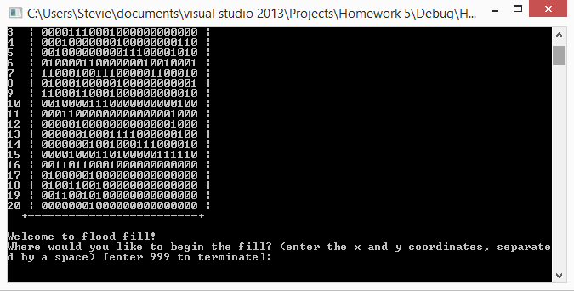

Example of instructions and original image passed

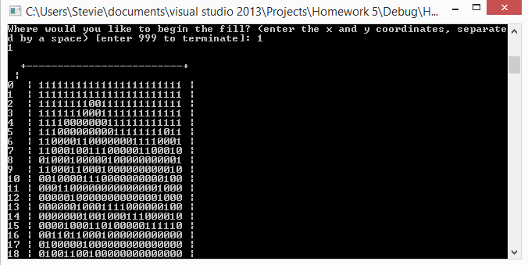

Example of user input and successful flood fill

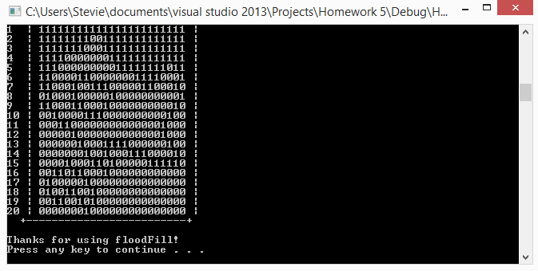

Example of “999” termination.

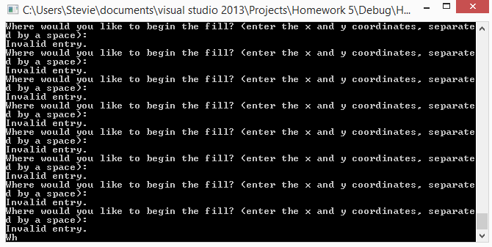

Trying to enter invalid input